PART 1. RDF, RDFS

Ex1. Give the following statements in natural language form
- SOICT is located at No. 1, Dai Co Viet, Hai Ba Trung, Hanoi
- Website https://soict.hust.edu.vn/ is the homepage of SOICT
- Resource URI1 is a course on Semantic Web, taught by Lecturer Hung in room B1-404

Write the sentences above in RDF, using at least 3 triples for each sentence

Ex2. Use RDF/RDFS to represent the following statements:
- Document 1 created by Minh
- Document 2 and Document 3 created by the same author (unknown)
- Document 3 states that Document 1 is published by W3C
Assume the URIs for the 3 documents are doc1, doc2, doc3. Some predicates about authors and publishers are dc:Creator and dc:Publisher, defined by Dublin Community at https://www.dublincore.org/specifications/dublin-core/dcmi-terms/

Ex 3. Use RDF/RDFS to represent the following statements:
- URI1 and URI2 are classes
- URI3 is a property
- URI4 is an instance of URI1
- URI5 and URI6 are instances of URI2
- URI3 has domain as URI1 and range as URI2

Ex 4. Represent the following graph in Turtle format.
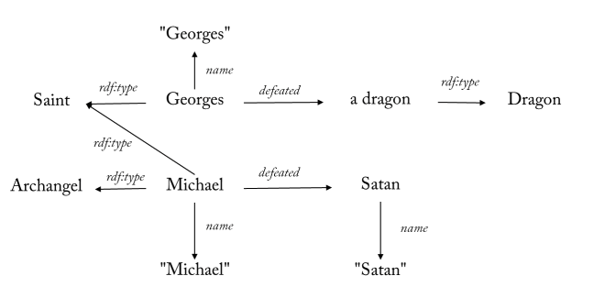
name is term in the foaf namespace: http://xmlns.com/foaf/0.1/
rdf is the prefix of the namespace: http://www.w3.org/1999/02/22-rdf-syntax-ns#

Ex 5. Create a graph describing the following relationship, then represent it as triples.
Professor (Professor) and Assistant (Assistant) are subclasses of Teacher class. Each Teacher has a name. Each Course has a courseID. The professor teaches the subject, while the teaching assistant supports the course management.

Ex 6. Build a graph to describe the following triples

PREFIX : <http://example.org/>
PREFIX rdf: <http://www.w3.org/1999/02/22-rdf-syntax-ns#>
PREFIX foaf: <http://xmlns.com/foaf/0.1/>

:Minh a :Teacher;
:teaches "Semantic Web" , "Data Integration" ;
foaf:member :SOICT .
[] foaf:knows :Minh; foaf:member [a :Company] .

Ex 7. Describe a library as a graph with information about book, author, publisher, year, etc. Write several RDF triples describing the data.

PART 2. RDFS

Ex 1. Describe the following ontology
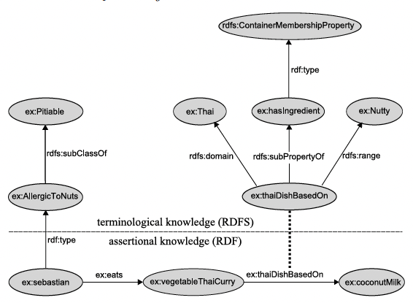
5 classes : Pitable, AllergicToNuts, Thai, Nutty, ContainerMembershipProperty,
2 properties: hasIngredient, thaiDishBasedOn
3 instance sebatian, vegetableThaiCurry, coconutMilk, eats
Ex 2. Give RDF file as follows

@prefix rdf:<http://www.w3.org/1999/02/22-rdf-syntax-ns#>.
@prefix rdfs:<http://www.w3.org/2000/01/rdf-schema#>.
@prefix :<http://example.com/terms#>.

:Person a rdfs:Class .
:Man a rdfs:Class;
rdfs:subClassOf :Person .
:Parent a rdfs:Class ;
rdfs:subClassOf :Person .
:Father a rdfs:Class;
rdfs:subClassOf :Parent ;
rdfs:subClassOf :Man .
:Child a rdfs:Class ;
rdfs:subClassOf :Person .
:hasParent a rdf:Property ;
rdfs:domain :Person ;
rdfs:range :Parent .
:hasFather a rdf:Property ;
rdfs:subPropertyOf :hasParent ;
rdfs:range :Father .
:isChildOf a rdf:Property ;
rdfs:domain :Child ;
rdfs:range :Parent .
:Ann a :Person ;
:hasFather :Carl .
:Carl a :Man .
Requirements:
A. Draw a graph to represent the above triples
B. Indicate whether the following statements are true or false
  - :Father rdfs:subClassOf :Person .
  - :Man rdfs:subClassOf :Person .
  - :Carl a :Person .
  - :Carl a :Parent .
  - :Carl :hasChild :Ann .
  - :Carl a :Man .
  - :Carl a :Father .
  - :Child rdf:type rdfs:Resource .
  - :Ann a :Child .
  - :Ann :isChildOf :Carl .
  - :Ann :hasParent :Carl .
  - :Ann :hasParent _:x .
  - :Ann :hasParent [ rdf:type :Person ] .
  - :hasFather rdfs:domain :Person .
  - rdfs:range rdf:type rdfs:Resource .
  - :hasFather rdfs:range :Father .
  - :hasFather rdfs:domain [ rdfs:subClassOf :Person ] .
  - :Father rdfs:subClassOf [ rdfs:subClassOf :Person ] .

PART 3. OWL

Ex 1. The pizza ontology is a well-known ontology in the semantic web community. It is developed for educational purposes by the University of Manchester, which is a leading university in the development of semantic technologies. The pizza ontology and a tutorial that uses it is found at
- http://owl.cs.manchester.ac.uk/publications/talks-and-tutorials/protg-owl-tutorial/
- http://protegewiki.stanford.edu/wiki/Protege4Pizzas10Minutes

1. Open the pizza.owl file in your browser to learn about this ontology. Download the file and open it with Protege. Then look at the definition of classes and attributes.

2. Find Margherita and see how it is defined as a pizza with only cheese and tomato topping. Look at the definition of VegetarianPizza. Is a Margherita pizza a vegetarian pizza? Why / why not?

3. Find hasIngredient. What is the domain and range of this property? What are the subproperties of hasIngredient? What is the inverse property of hasIngredient? What property characteristics does hasIngredient have?

4. Classify the ontology by choosing a reasoner and then “classify” in the reasoner menu. In the “Inferred class hierarchy” two classes show up as subclasses of owl:Nothing. Answer the following questions:
- In general, what is the difference between the asserted class hierarchy and the inferred class hierarchy?
- What does it mean for a class to be a subclass of owl:Nothing?
- Explain why these two classes appear as subclasses of owl:Nothing.
- Find Margherita in the inferred class hierarchy and see which classes are inferred as superclasses of Margherita.

5. Add a new class Grandiosa as a subclass of NamedPizza. Define “Grandiosa” as something which
- hasTopping some HamTopping,
- hasTopping some TomatoTopping and
- hasTopping some CheeseTopping. Classify the ontology.
What superclasses are inferred as superclass of Grandiosa? Explain why

6. State in the ontology that a Grandiosa pizza comes from Norway, and that Norway is different from the other countries already present in the pizza ontology. Apply reasoning and explain the results

Ex 2. Give an ontology with the following representation. Please describe this ontology using OWL.
- Medicinal products include over-the-counter drugs and prescription based drugs. Each drug consists of an active substance. In addition, each drug can be replaced by zero or more other drugs.
- Panadol is an instance of an over-the-counter drug. Tramadol is an instance of a prescription based drug. Loperamide is an instance of the active substance.

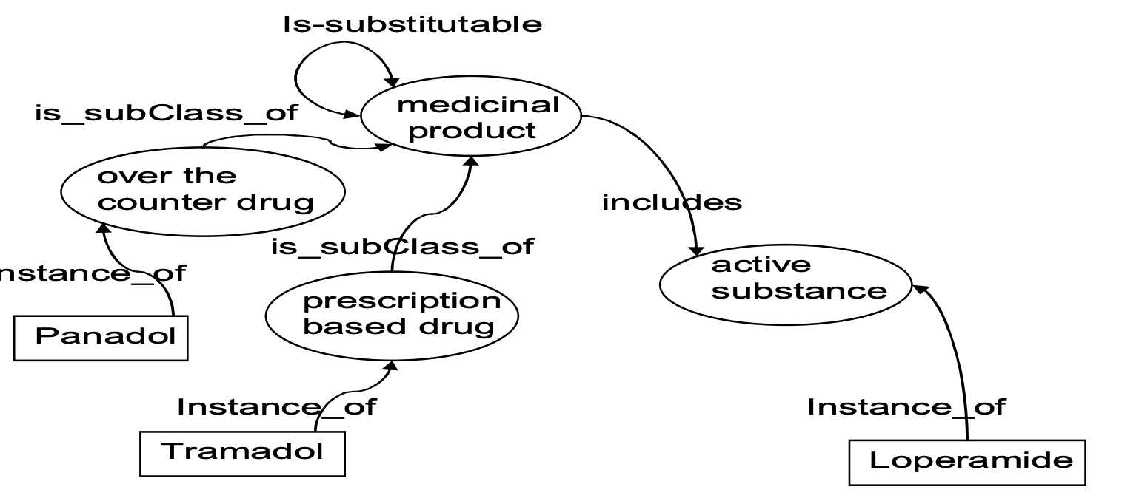

Ex3. Give an ontology with the following representation. Please describe this ontology using OWL.
A laboratory-course is a course. Courses are organized by teachers. Teachers can be professors or assistants. The professor teaches the courses, while the assistant only teaches the practical courses. Homework is part of the course.
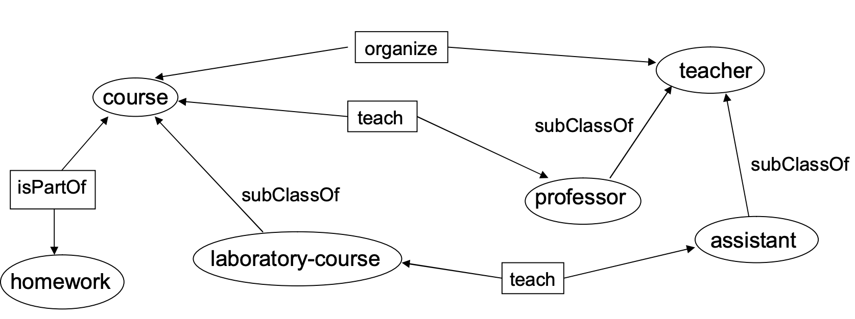

Ex4. Give a description about film as follows:
film:avatar a :Movie ;
dc:title "Avatar"@en ;
:director people:james ;
:leading-actor people:sam ;
:leading-actor people:zoe ;
:supporting-actor people:michelle .
people:james a :Man ;
foaf:name "James Cameron" .
people:sam a :Man ;
foaf:name "Sam Worthington" .

people:zoe a :Woman ;
foaf:name "Zoe Saldana" .

people:michelle a :Woman ;
foaf:name "Michelle Rodriguez".

Class: Movie, Man, Woman, Person, LoveMovie, AnimalDocumentary, AnimatedMovie
Property: title, director, leading-actor, supporting-actor, actor, male-lead, female-lead

Create an ontology with the following descriptions:
- Any Man or Woman is a Person, and Person can only be Man or Woman, not both Man and Woman.
- A leading actor and a supporting actor are both actors.
- A “male-lead” is a Man
- A “female-lead” is a Woman
- Any “male lead” or “female lead” is a leading actor, any leading actor or supporting actor is an actor. (Note: these are all roles linking movies to people.)
- A love movie has at least one male leading actor and one female leading actor
- A film without an actor is either an Animal Documentary or an Animated Movie.

